**LINUX**

**Topic A – Productivity & Application Software**

This task manager shows you all the running processes and their memory consumption. You can choose to end a process from this task manager application. When you have just begun with Linux, you look for a **task manager equivalent in Linux** as well. An expert Linux user prefers the command line way to find processes and memory consumption etc but you don’t have to go that way, at least not when you are just starting with Linux. All major Linux distributions depends on your Linux have a task manager equivalent. Mostly, **it is called System Monitor** but it actually distribution and the [desktop environment](https://wiki.archlinux.org/index.php/desktop_environment) it uses.

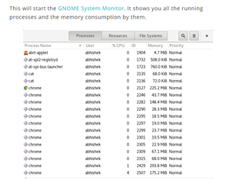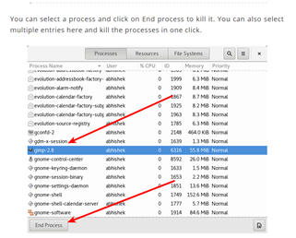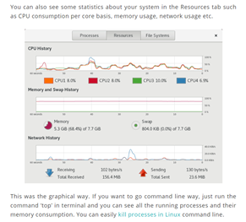

<https://itsfoss.com/task-manager-linux/>

version *1.1.0*:

* § You can now filter notes by tag in the search box, including multiple tags. For example, if you wanted to search for notes tagged ‘travel’ and ‘poetry’, you would enter ‘tag:travel tag:poetry’ in the search bar.
* § We’ve made some UI improvements to the app, including better support for running the app at smaller screen sizes and a new placeholder view that shows when there are no notes to display in the app.
* § Many performance and reliability updates.
* § A security fix related to cross-site scripting in the markdown preview.
* version *1.1.0*:
* § You can now filter notes by tag in the search box, including multiple tags. For example, if you wanted to search for notes tagged ‘travel’ and ‘poetry’, you would enter ‘tag:travel tag:poetry’ in the search bar.
* § We’ve made some UI improvements to the app, including better support for running the app at smaller screen sizes and a new placeholder view that shows when there are no notes to display in the app.
* § Many performance and reliability updates.
* § A security fix related to cross-site scripting in the markdown preview.

a bug fix release that includes:

* A fix for notes sometimes not syncing when the connection went offline.
* Links now open in an external browser instead of an internal window.
* Small design improvements.
* History: drag the History slider to view previous versions.
* Collaboration: share your note with others and allow them to edit.
* Publishing: make your note public with its own URL.
* Tags: organize your notes effectively with tags.
* Pinning: pin notes right from the note list so they’re easy to find.

<https://simplenote.com/category/linux/>

[FocusWriter](https://gottcode.org/focuswriter/) is a text processor that creates a distraction-free environment for writers. It supports popular text formats and uses a hide-away interface to block out all distractions. You can select any visual and sound theme that works best for your productivity, and focus on your work. FocusWriter also allows you to set daily goals, use timers, alarms, and look into statistics.

[Osmo](https://sourceforge.net/projects/osmo-pim/) is a personal organizer. It includes various modules: calendar, notes, tasks list and reminder, and contacts. It is a lightweight and easy to use tool for managing all important personal information. The app can run both in an open window or in the background mode, and it doesn’t need an Internet connection.Osmo offers various configuration and formatting options for different types of information you record in it: addresses, birthdays, ideas, events, etc. Its handy search allows to find and access necessary information quickly and easily.

<https://www.fossmint.com/linux-productivity-tools/>

**Topic B – Entertainment & Media Software**

* Kodibuntu
* featuring a 10-foot user interface for use with televisions and remote controls. It allows users to play and view most videos, music, podcasts, and other digital media files from local and network storage media and the internet

The official Kodi version does not contain any content what so ever. This means that you should provide your own content from a local or remote storage location, DVD, Blu-Ray or any other media carrier that you own. Additionally Kodi allows you to install third-party plugins that may provide access to content that is freely available on the official content provider website. The watching or listening of illegal or pirated content which would otherwise need to be paid for is not endorsed or approved by Team Kodi.

<https://nactvbox.wordpress.com/2016/06/13/kodi-facts-what-exactly-is-kodi-and-what-does-it-do/>

* Mythbuntu

Watching what you want when you want is a luxury that’s been perpetuated by on-demand, digital delivery, and DVR. MythTV was developed to enhance the DVR experience, and Mythbuntu adds the functionality of Ubuntu. The interface is tailored for a DVR format, with options to watch live TV, manage recordings, and view a media library.

Mythbuntu is perfect for those seeking a simple yet powerful DVR management solution to integrate with a TV tuner, this is it. As someone sans-TV tuner, I tried it for local playback which did work, but if you’re like me and don’t have a tuner, you’re better off with a solution like Kodibuntu or GeeXbox

* gaming

Ubuntu’s software support doesn’t end with applications. Game developers often port their titles with Ubuntu in mind. The Steam website provides a Linux client aimed at Ubuntu. GOG.com only officially supports Ubuntu (and the Ubuntu-based Linux Mint).

These sites and the games they distribute aren’t limited to Ubuntu. You can find ways to run them on other Linux-based operating systems. Some even [make Linux gaming an easy job](https://www.makeuseof.com/tag/best-linux-gaming-operating-systems/).

[5 Best Linux Operating Systems for Gaming](https://www.makeuseof.com/tag/best-linux-gaming-operating-systems/) [**5 Best Linux Operating Systems for Gaming**](https://www.makeuseof.com/tag/best-linux-gaming-operating-systems/)Linux isn't ideal for gaming, but it's absolutely possible! Here are five Linux distributions made specifically for gaming.**[READ MORE](https://www.makeuseof.com/tag/best-linux-gaming-operating-systems/)**

But if things go wrong, the Ubuntu version is the one you where you can expect to receive help from game distributors or developers. Elsewhere, you will have to turn to the broader community and cross your fingers that fixes exist.

.

<https://www.makeuseof.com/tag/awesome-linux-media-center-distros-htpc/>

**Topic C – Programming Tools & Environment**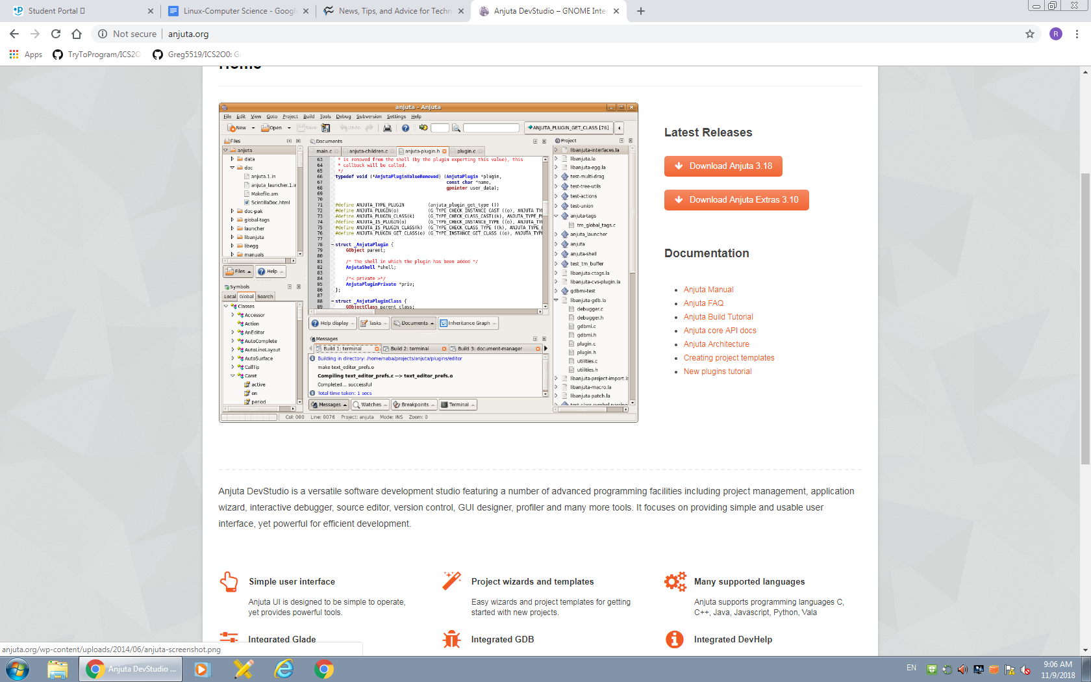

2: Anjuta

## [Anjuta](http://anjuta.sourceforge.net/) is a free, open source IDE for the C and C++ languages. It's easy to install (*urpmi anjuta* on Mandriva, for example) and offers such features as project management, application wizards, an interactive debugger, and a powerful source code editor (with source browsing, code completion, and syntax highlighting). The Anjuta team developed this powerful IDE to be easy to use and still meet all of your C and C++ programming needs.

Anjuta has a flexible and powerful user interface that allows you to drag and drop the tools in the layout to arrange the GUI nearly any way you like. And each user-configured layout is persistent for the project (so you can have different layouts for every project you have going). Anjuta also enjoys a powerful plug-in system that allows you to decide which plug-ins are active and which are not for each project. And like all open source projects, you can develop your own plug-ins for Anjuta. One of the most powerful tools in the Anjuta application is the project manager. This tool can open nearly any automake/autoconf-based project. This project manager doesn't add any Anjuta-based information to the project, so your project can be maintained and developed outside of Anjuta as well.

## 3: Glade

[Glade](http://glade.gnome.org/) is a RAD (rapid application development) tool used to create GTK+ toolkit and for the GNOME desktop. Its interface is similar to that of The GIMP and can be customized and even embedded into Anjuta. Glade includes a number of interface building blocks, such as text boxes, dialog labels, numeric entries, check boxes, and menus, to make the development of interfaces quicker. Interface designs are stored in XML format, which allows these designs to be easily interfaced with external tools. Installing Glade is simple. For instance, when in Fedora, you can issue the command *yum install glade3.* Glade does not have as powerful a project manager as Anjuta, but you can create, edit, and save projects with Glade.

## **4: GCC**

## [GCC](http://gcc.gnu.org/) is a GNU compiler that works for C, C++, Objective C, FORTRAN, Java, and Ada. It's a command-line tool but is very powerful. Many IDEs have tools that are merely front ends for GCC. GCC is actually a set of tools. The most used are the compilers for C and C++ code. How does one tool compile for different languages? Simple: For C, you invoke the "gcc" command and for C++, you invoke the "g++" command. Two compilers in the same toolkit. And g++ is a compiler, not just a preprocessor. It will build object code from source code without using an intermediary to first build C code from C++ source. This creates better object code and gives you better debugging information.

<https://www.techrepublic.com/blog/10-things/10-linux-and-open-source-developer-tools-you-should-not-overlook/>

**Topic D – System Tools**

* **The Bootloader:** The software that manages the boot process of your computer. For most users, this will simply be a splash screen that pops up and eventually goes away to boot into the operating system.
* **The kernel:** This is the one piece of the whole that is actually called “Linux”. The kernel is the core of the system and manages the CPU, memory, and peripheral devices. The kernel is the “lowest” level of the OS.
* **Daemons:** These are background services (printing, sound, scheduling, etc) that either start up during boot, or after you log into the desktop.
* **The Shell:** You’ve probably heard mention of the Linux command line. This is the shell – a command process that allows you to control the computer via commands typed into a text interface. This is what, at one time, scared people away from Linux the most (assuming they had to learn a seemingly archaic command line structure to make Linux work). This is no longer the case. With modern desktop Linux, there is no need to ever touch the command line.
* **Graphical Server:** This is the sub-system that displays the graphics on your monitor. It is commonly referred to as the X server or just “X”.
* **Desktop Environment:** This is the piece of the puzzle that the users actually interact with. There are many desktop environments to choose from (Unity, GNOME, Cinnamon, Enlightenment, KDE, XFCE, etc). Each desktop environment includes built-in applications (such as file managers, configuration tools, web browsers, games, etc).
* **Applications:** Desktop environments do not offer the full array of apps. Just like Windows and Mac, Linux offers thousands upon thousands of high-quality software titles that can be easily found and installed. Most modern Linux distributions (more on this in a moment) include App Store-like tools that centralize and simplify application installation. For example: Ubuntu Linux has the Ubuntu Software Center (Figure 1) which allows you to quickly search among the thousands of apps and install them from one centralized location.

<https://www.linux.com/what-is-linux>

A typical Linux server runs in a command line interface (CLI) environment, preloaded with bare essential tools needed to install and configure various headless services. Compared to a full-blown GUI desktop image, such a minimal setup is advantageous in terms of security, resource consumption and speed.

<https://www.linux.com/learn/how-manage-linux-server-gui>

**Topic E – Software Security & Updates**

1. [ClamAV](http://www.clamav.net/lang/en/)

My favorite antivirus software for Linux is Sourcefire's ClamAV, a free, [open source](http://www.pcworld.com/businesscenter/article/209891/10_reasons_open_source_is_good_for_business.html) package designed to detect Trojans, viruses, malware and other malicious threats. Included in the software, which now comes preinstalled in several [Linux distributions](http://www.pcworld.com/businesscenter/article/204767/a_guide_to_todays_top_10_linux_distributions.html), are a multithreaded scanning daemon, command line utilities for on-demand file scanning, and an intelligent tool for automatic signature updates. Of particular note for past or current Windows users is that the core ClamAV library is also used in [Immunet 3.0](http://www.immunet.com/), a sister solution for Microsoft's operating system.

2. [Snort](http://www.snort.org/)

Also offered by Sourcefire is Snort, an open source network intrusion prevention and detection system that combines the benefits of signature, protocol and anomaly-based inspection. With millions of downloads and more than 300,000 registered users to its credit, Snort is the most widely deployed such technology worldwide, Sourcefire says.

**3. [Wireshark](http://www.wireshark.org/)**

Wireshark is a network protocol analyzer that lets you capture and interactively browse the traffic running on a computer network. The software runs not just on Linux but on Windows, OS X, Solaris, FreeBSD and NetBSD, as well. Captured network data can be browsed via GUI or via the TTY-mode TShark utility.

<https://www.pcworld.com/article/224955/7_free_security_tools_for_linux.html>

Ubuntu Linux has become one of the most popular of all the Linux distributions. And through the process of updating a system, you should be able to tell exactly why this is the case. Ubuntu is very user friendly. Ubuntu uses two different tools for system update:

* apt-get: Command line tool.
* Update Manager: GUI tool.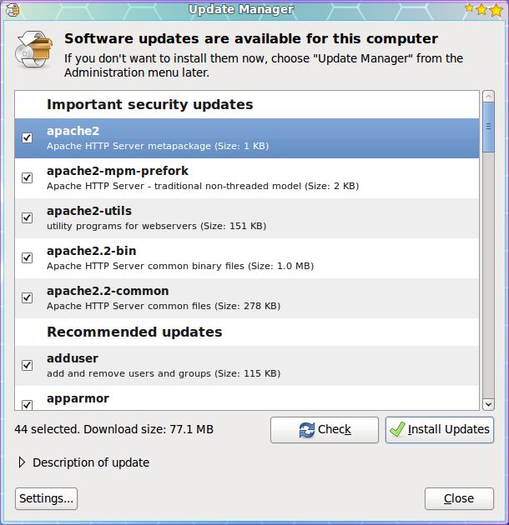

The Update Manger is a nearly 100% automatic tool. With this tool you will not have to routinely check to see if there are updates available. Instead you will know updates are available because the Update Manager will open on your desktop (see Figure 1) as soon as the updates depending upon their type:

* Security updates: Daily
* Non-security updates: Weekly

If you want to manually check for updates, you can do this by clicking the Administration sub-menu of the System menu and then selecting the Update Manager entry. When the Update Manager opens click the Check button to see if there are updates available.

Figure 1 shows a listing of updates for a Ubuntu 9.10 installation. As you can see there are both *Important Security Updates* as well as *Recommended Update*. If you want to get information about a particular update you can select the update and then click on the *Description of update* dropdown.

In order to update the packages follow these steps:

1. Check the updates you want to install. By default all updates are selected.
2. Click the Install Updates button.
3. Enter your user (sudo) password.
4. Click OK.

The updates will proceed and you can continue on with¬† your work. Now some updates may require either you to log out of your desktop and log back in, or to reboot the machine. There are is a new tool in development ([Ksplice](http://www.ksplice.com/))¬† that allow even the update of a kernel to not require a reboot.

Once all of the updates are complete the Update Manage main window will return reporting that *Your system is up to date*.

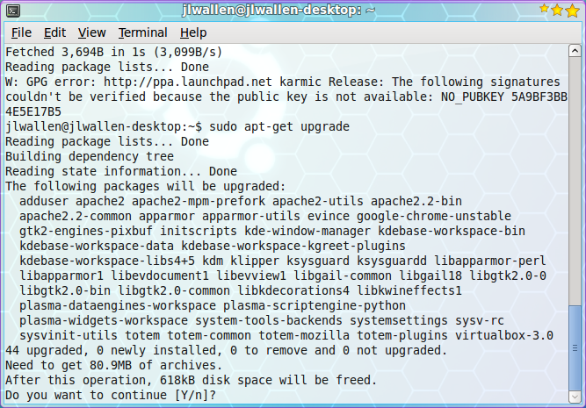Now let's take a look at the command line tools for updating your system. The Ubuntu package management system is called *apt*. Apt is a very powerful tool that can completely manage your systems packages via command line. Using the command line tool has one drawback - in order to check to see if you have updates, you have to run it manually. Let's take a look at how to update your system with the help of Apt. Follow these steps:

1. Open up a terminal window.
2. Issue the command *sudo apt-get upgrade*.
3. Enter your user's password.
4. Look over the list of available updates (see Figure 2) and decide if you want to go through with the entire upgrade.
5. To accept all updates click the 'y' key (no quotes) and hit Enter.
6. Watch as the update happens.

That's it. Your system is now up to date.

<https://www.linux.com/learn/linux-101-updating-your-system>

**Topic F – File System & User Accounts**

Linux/Unix operating systems have the ability to multitask in a manner similar to other operating systems. However, Linux’s major difference from other operating systems is its ability to have multiple users. Linux was designed to allow more than one user to have access to the system at the same time. In order for this multiuser design to work properly, there needs to be a method to protect users from each other. This is where permissions come in to play.

* To view the permissions on a file or directory, issue the command ls -l <directory/file>. Remember to replace the info
* rmation in the < > with the actual file or directory name. Below is sample output for the ls command:
* -rw-r--r-- 1 root root 1031 Nov 18 09:22 /etc/passwd
* The first ten characters show the access permissions. The first dash (-) indicates the type of file (d for directory, s for special file, and - for a regular file). The next three characters (rw-) define the owner’s permission to the file. In this example, the file owner has read and write permissions only. The next three characters (r–) are the permissions for the members of the same group as the file owner (which in this example is read only). The last three characters (r–) show the permissions for all other users and in this example it is read only.

<https://www.linode.com/docs/tools-reference/linux-users-and-groups/>

### Three files defines a user account

### /etc/passwd file

ram:x:1003:1003:ram kumar:/home/ram:/bin/bash  
charvi:x:1004:1004:charvi gite:/home/charvi:/bin/bash  
vivek:x:1005:1005:vivek gite:/home/vivek:/bin/bash

### /etc/group file

prouser:x:1001:vivek,charvi  
ram:x:1003:  
charvi:x:1004:  
Vivek:x:1005:

### /etc/shadow file

ram:$1$4tuS/iYO$CsmE8cD7j/96ca7K3gJ9Y/:13061:0:99999:7:::  
charvi:$1$4tuS/iYO$CsmE8cD7j/96ca7K3gJ9Y/:13066:0:99999:7:::  
vivek:$1$4tuS/iYO$CsmE8cD7j/96ca7K3gJ9Y/:13064:0:99999:7:::

<https://www.cyberciti.biz/faq/linux-what-defines-a-user-account/>

### **Structure**

It makes sense to explore the Linux filesystem from a terminal window, not because the author is a grumpy old man and resents new kids and their pretty graphical tools -- although there is some truth to that -- but because a terminal, despite being text-only, has better tools to show the map of Linux's directory tree.

In fact, that is the name of the first tool you'll install to help you on the way: *tree*. If you are using Ubuntu or Debian, you can do:

sudo apt install tree

On Red Hat or Fedora, do:

sudo dnf install tree

For SUSE/openSUSE use zypper:

sudo zypper install tree

For Arch-like distros (Manjaro, Antergos, etc.) use:

sudo pacman -S tree

... and so on.

Once installed, stay in your terminal window and run *tree* like this:

tree /

The / in the instruction above refers to the *root* directory. The root directory is the one from which all other directories branch off from. When you run tree and tell it to start with */*, you will see the whole directory tree, all directories and all the subdirectories in the whole system, with all their files, fly by.

If you have been using your system for some time, this may take a while, because, even if you haven't generated many files yourself, a Linux system and its apps are always logging, cacheing, and storing temporal files. The number of entries in the file system can grow quite quickly.

Don't feel overwhelmed, though. Instead, try this:

tree -L 1 /

And you should see what is shown in Figure 1.[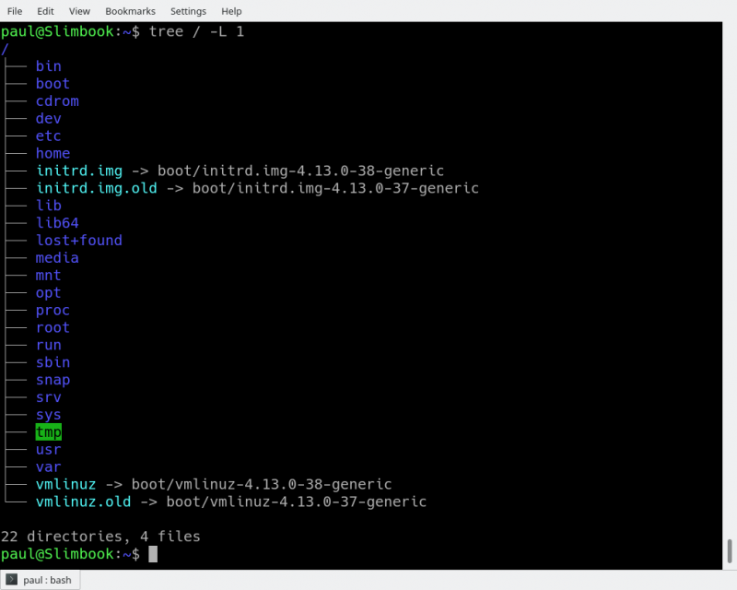](https://www.linux.com/files/images/f01tree01png)

#### ***/media***

The */media* directory is where external storage will be automatically mounted when you plug it in and try to access it. As opposed to most of the other items on this list, */media* does not hail back to 1970s, mainly because inserting and detecting storage (pendrives, USB hard disks, SD cards, external SSDs, etc) on the fly, while a computer is running, is a relatively new thing.

#### ***/mnt***

The */mnt* directory, however, is a bit of remnant from days gone by. This is where you would manually mount storage devices or partitions. It is not used very often nowadays.

#### ***/opt***

The */opt* directory is often where software you compile (that is, you build yourself from source code and do not install from your distribution repositories) sometimes lands. Applications will end up in the */opt/bin* directory and libraries in the */opt/lib* directory.

A slight digression: another place where applications and libraries end up in is */usr/local*, When software gets installed here, there will also be */usr/local/bin* and */usr/local/lib* directories. What determines which software goes where is how the developers have configured the files that control the compilation and installation process.

<https://www.linux.com/blog/learn/intro-to-linux/2018/4/linux-filesystem-explained>

**Topic G – Special Features of your OS**

* Kernel − Kernel is the core part of Linux. It is responsible for all major activities of this operating system. It consists of various modules and it interacts directly with the underlying hardware. Kernel provides the required abstraction to hide low level hardware details to system or application programs.
* System Library − System libraries are special functions or programs using which application programs or system utilities accesses Kernel's features. These libraries implement most of the functionalities of the operating system and do not requires kernel module's code access rights.
* System Utility − System Utility programs are responsible to do specialized, individual level tasks.

<https://www.tutorialspoint.com/operating_system/os_linux.htm>

**Customized Keyboards**

Linux OS has many users across the globe, so they provided it to be available in multiple languages and customer support. This feature includes customized keyboards that have the accessible languages for different nations. With this, it is a user – friendly and easy to use a system that meets everybody’s standards.

**Live CD Or USB**

Most of all the distributed Linux systems come with a Live CD or USB feature in which a user can use and run the operating system without the need of installing it to your computer or laptop. You can be assured that Linux can offer you a wide range of options based on your requirements.

**Application Support**

A Linux OS comes with a software repository in which a user can easily download or install a huge amount of applications by just providing a command to the terminal or shell of Linux. Linux OS can also be possible to run a Windows application.

**Graphical User Interface**

If you think Linux is only a command line operating system, you might be true but not really to its extent. You should know that Linux comes with packages in which it is possible to install to make its complete operating system graphics to be based on Windows.

**Good Security**

This feature can also be a good characteristic of Linux OS because it prioritizes the protection of the confidential works of the users from hackers or persons who are not authorized to enter their system. Linux provided some security concepts which include Authentication, Authorization, and especially Encryption. With these security concepts, it only goes to show that Linux OS is safe to use and prevent the access of any unauthorized people that might have bad intentions.

With all the information stated above, you now know what are the best features of Linux Operating System. You should also know that these features make it perform to its maximum and will surely amaze every user of it. In this way, you can be assured that you can have the excellent and high-quality operating system that you wish you can have. If you want to know more about Linux Operating System, you can ask an expert on this topic or visit their website.

<https://www.linuxchange.org/5-best-features-of-linux-operating-system-that-you-need-to-know/>

Linux was one of the first open-source technologies, but many programmers have contributed and added software that’s completely open-source for any user. This means that you can download the source code and change it any way you like. Some developers have restrictions on how you can distribute the code. For instance, some developers allow you to change the code, but you cannot distribute it for money.

One main advantage of [open-source](http://opensource.org/osd-annotated) technologies such as Linux is the wide range of options available to users and the increased security. With Linux being open-source, several distributions are available to the end-user. Debian, Fedora, Ubuntu and Mint are just a few of the distributions available to end users, and these distributions are completely free to download.

Security is the other main advantage. Several whitehat hackers have contributed to the overall security of Linux, and by making the source available to anyone, security experts can help identify any main security flaws in the operating system. The advantage over operating systems such as Windows is that security flaws are caught before they become an issue for the public.

<https://blog.storagecraft.com/linux-advantages-disadvantages-open-source-technology/>

**Topic H – Limitations of your OS**

Because Linux does not dominate the market like Windows, there are some disadvantages to using the operating system. First, it’s more difficult to find applications to support your needs. This is an issue for mostly businesses, but more programmers are developing applications that are supported by Linux. Many more applications are available for the working world compared to what was available a decade ago.

One main issue with Linux is drivers. Before you can install any hardware component in your computer, you must make sure the hardware has drivers available. Hardware manufacturers usually write drivers for Windows, but not all brands write drivers for Linux. This means that some of your hardware might not be compatible with Linux if you decide to switch.

Support for open-source can also be an issue. While there are plenty of Windows support people, Linux is not supported out-of-the-box. The way Linux distribution companies make money is through their support channels. This means that companies must pay fees for support, if they cannot solve an issue. However, there are plenty of forums and blogs that support Linux issues. If your company has a good Linux administrator, the administrator can typically find answers through one of these free channels without paying for support.

Before you decide on open-source technology, make sure you have the resources and personnel to support the software.

<https://blog.storagecraft.com/linux-advantages-disadvantages-open-source-technology/>

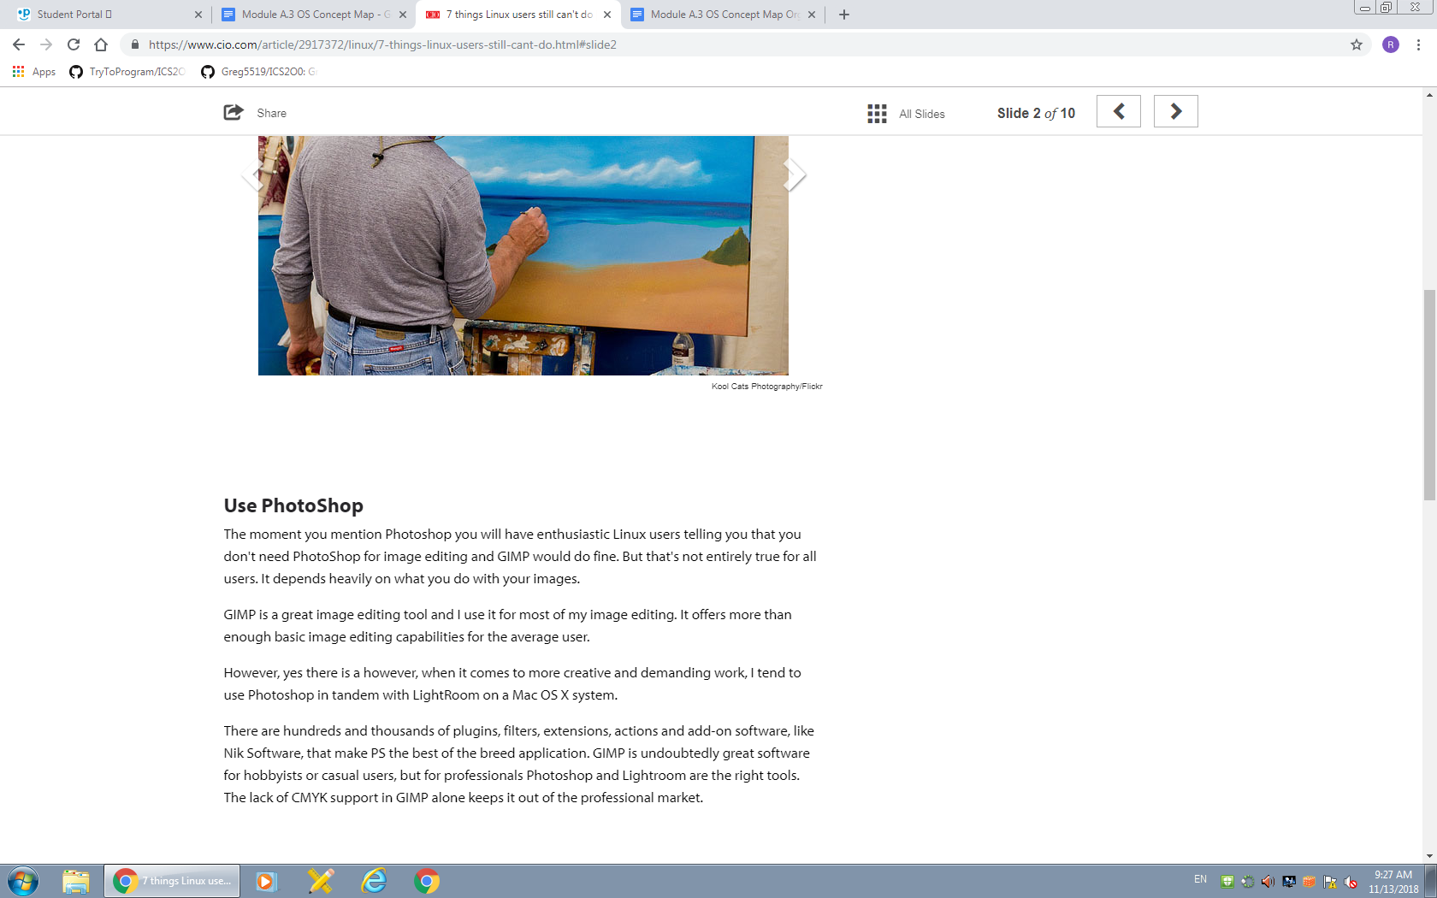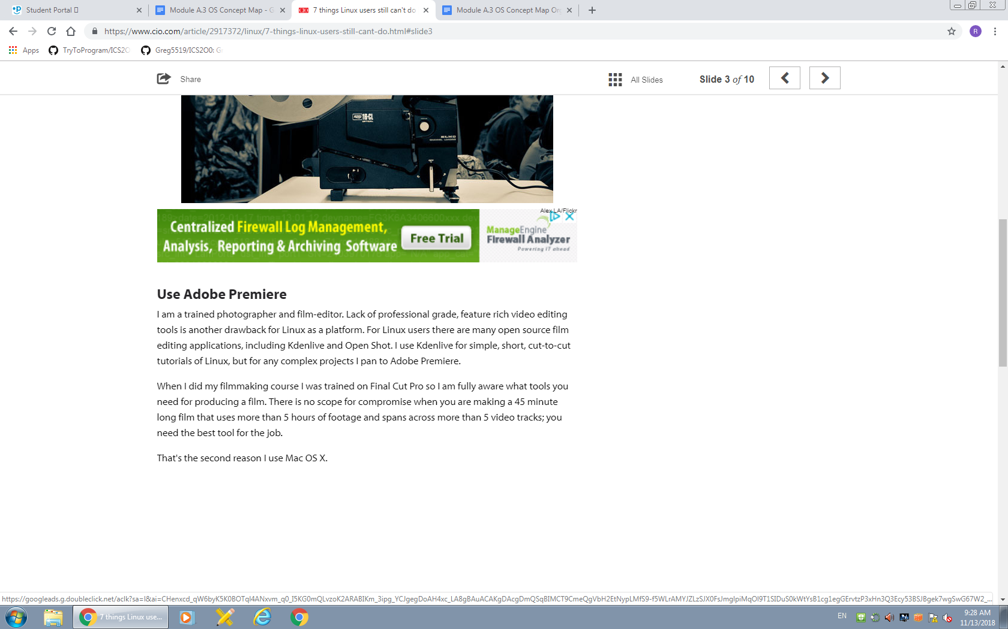[****](https://www.cio.com/article/2917372/linux/7-things-linux-users-still-cant-do.html#slide2)

<https://www.cio.com/article/2917372/linux/7-things-linux-users-still-cant-do.html#slide2>